**A few things during installation:**

* Had to install Windows Subsystem for Linux (I am pretty sure this is necessary). Accessible using bash (and pretty sweet). **Try maybe upgrading to WSL 2 (not sure if done)**
* Had to install at least 2 programs on the Linux subsystem (swig.exe and unzip)
* Used the docker shit, do not know if it worked since I still installed quite a lot by myself.
* Installed an awesome tool for Linux called dos2unix to fix all the endings which I saw were problematical.
* Got the following warning quite a few times, consider doing if things stop working:
  + WARNING: The scripts pysc2_agent, pysc2_play and pysc2_replay_info are installed in '/home/t8637523/.local/bin' which is not on PATH.
  + Consider adding this directory to PATH or, if you prefer to suppress this warning, use --no-warn-script-location.
  + **export PATH=$PATH:**/home/t8637523/.local/bin

**Helpful:**

* Show starcraft shit
  + python3 -m pysc2.bin.play --norender --rgb_minimap_size 0 --replay NAME.SC2Replay
* Train on starcraft
  + python3 src/main.py --config=qmix --env-config=sc2 with env_args.map_name=2s3z
* Train on MultiCartpole
  + python3 src/main.py --config=qmix --env-config=multi_cart

**Running Example of Starcraft**

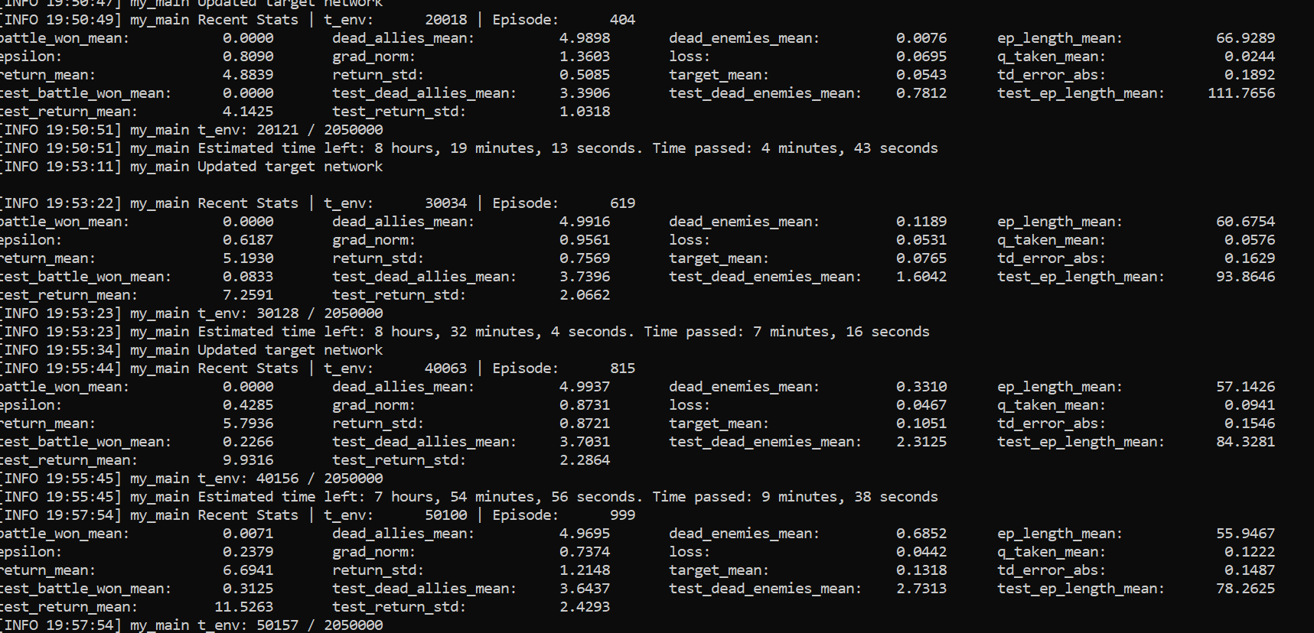

**Starcraft Environment**

* <https://github.com/oxwhirl/smac/blob/master/smac/env/starcraft2/starcraft2.py>

**Rewards Problem – they go for global rewards I think. Can be bypassed**

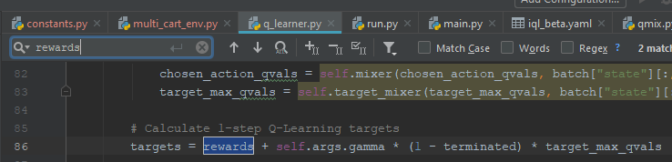

**Traffic Control Env**

* Needs the SUMO package (under scripts, ubuntu_setup.sh)
* Plus some other regular things like matplotlib

**Development steps:**

1. **Get the 5 networks working on the CartPole Example**
   1. **Visualize?**
2. **Make the Cartpole example Coupled**
3. **Implement Global – Local Rewards. Sum up Local rewards for local**
4. Implement Local Q-mix
   1. Make Work
   2. **Compare to Other ALogirthms**
5. **Find Out why regular Q-mix kinda fails on Cartpole ☹**
   1. IQL works great though for the non-coupled scenario
      1. Not true – doesn’t always work
   2. This is currently the most crucial step. If QMIX inherently fails on cartpole, it is a real shame and we need to switch model. Also need to check if this is inherent or not
      1. Play aggressively with hyper parameters
6. Check out weighted QMIX
   1. Interesting, kinda irrelevant for now.